CS 255 System Design Document Template

This template lays out all the different sections that you need to complete for Project Two. Each section has guidance to prompt your thinking. You will need to continually reference the interview transcript as you work to make sure that you are addressing your client’s needs. There is no required length for the final document. Instead the goal is to complete each section based on what your client’s needs are. Remove this note when you are finished, and replace all bracketed text with the relevant information.

UML Diagrams

UML Use Case Diagram
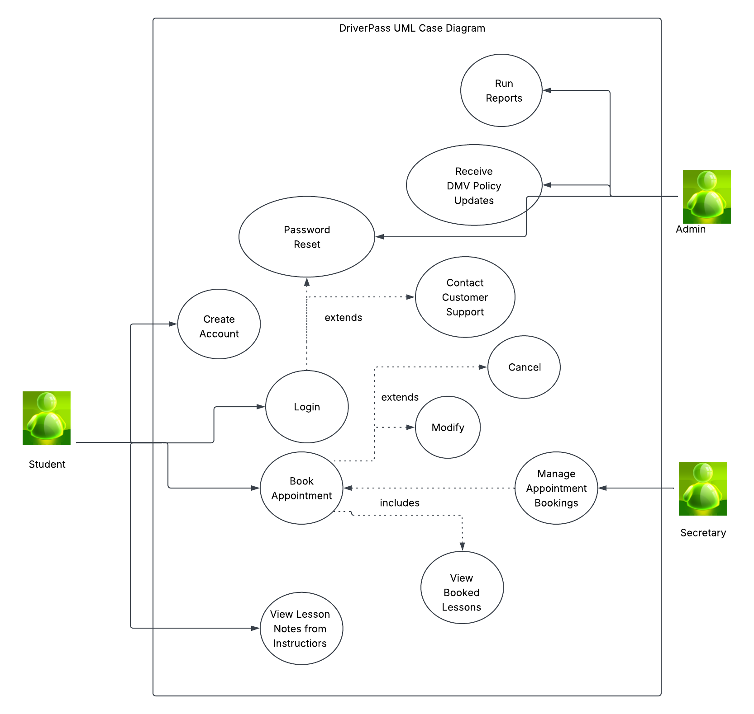

UML Activity Diagrams
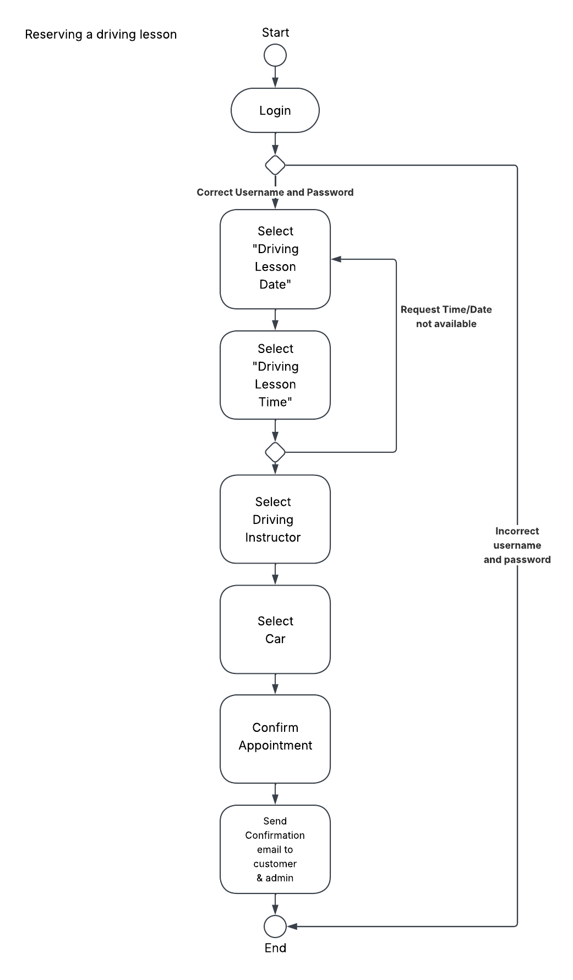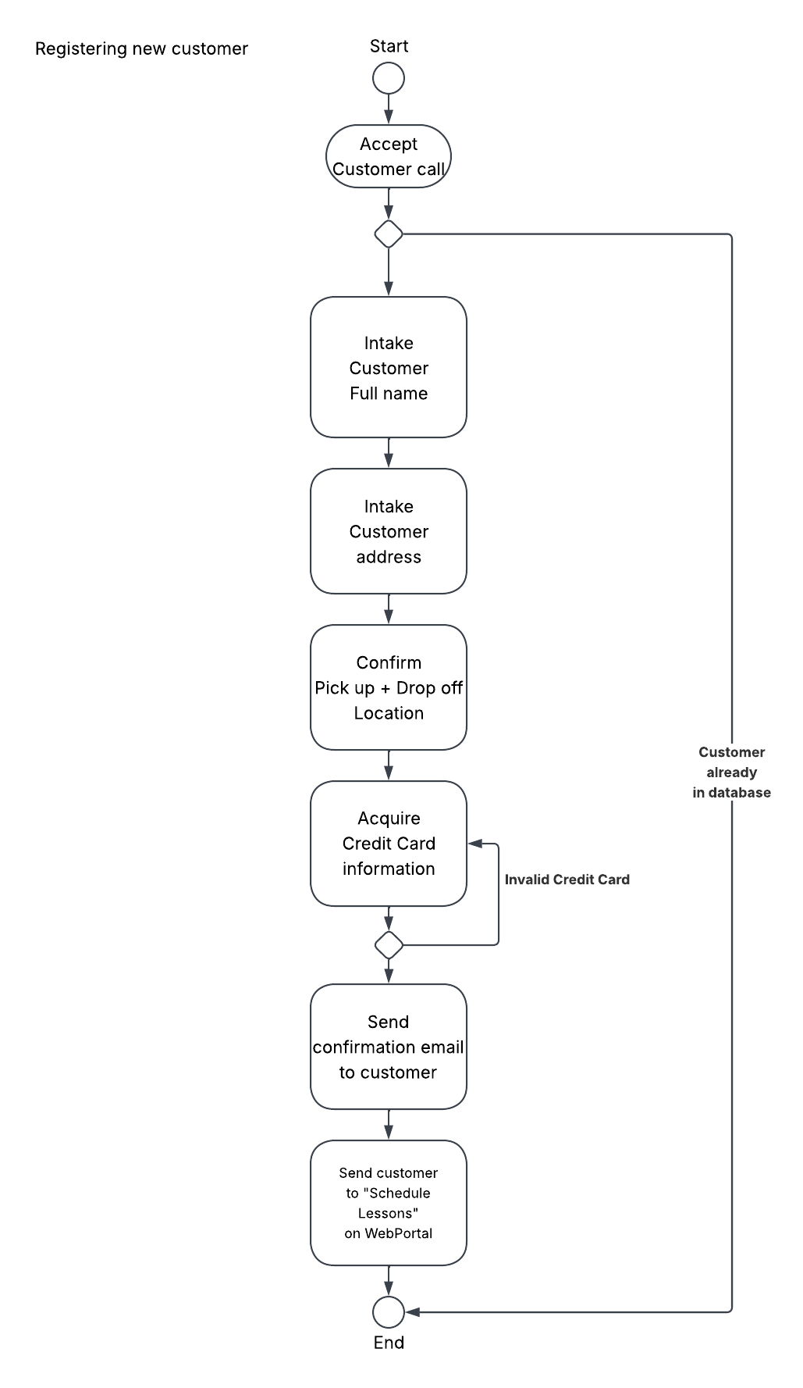

UML Sequence Diagram
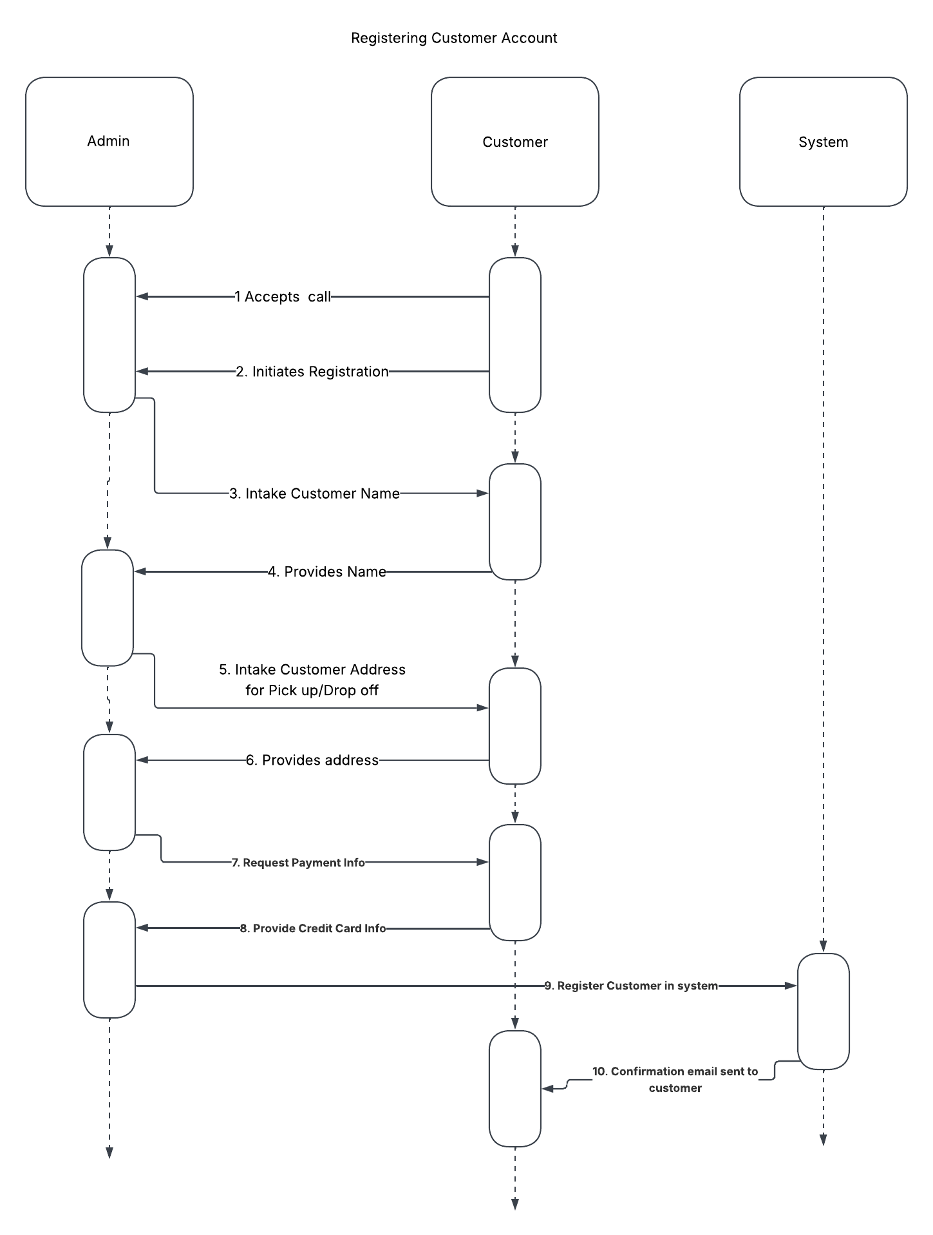

UML Class Diagram
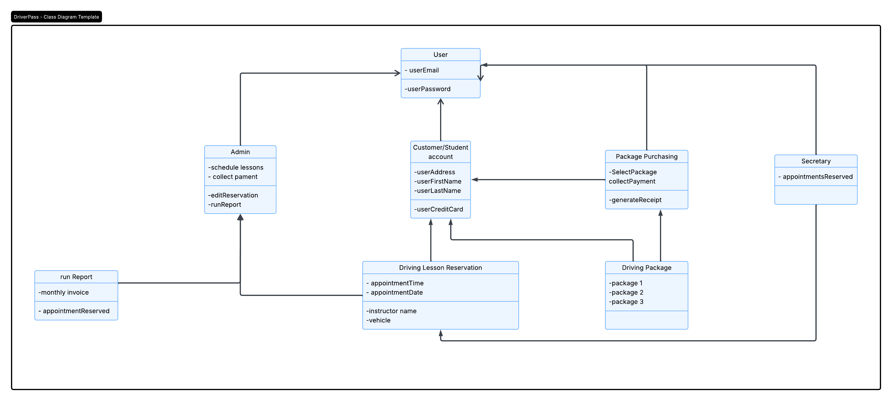

Technical Requirements

To support the organization's current operations while allowing for future growth, the learning management system (LMS) should be hosted on a cloud-based Linux server using an Infrastructure-as-a-Service (IaaS) provider such as Amazon Web Services (AWS) or Google Cloud. The application should utilize scalable architecture through Docker containers orchestrated by Kubernetes to accommodate increased user demand. Communication between system components should be facilitated through RESTful APIs, while the LMS should adhere to SCORM standards to ensure compatibility with industry-standard training content. Sensitive data should be protected using a hybrid encryption approach that combines RSA and AES encryption, with all network traffic secured using TLS 1.2 or higher. The web application should also comply with Progressive Web App (PWA) standards to provide consistent experience across devices and browsers. Compatibility testing should include major desktop and mobile platforms, including Windows, macOS, Android, and iOS, as well as modern web browsers such as Chrome. To ensure reliability, the system should maintain a minimum uptime of 99.5%, and reporting features should support data exports in CSV format for ease of use and integration with other business applications.

